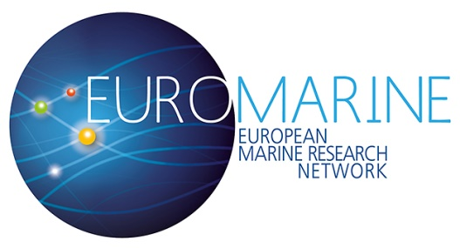
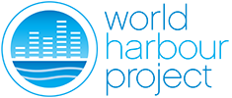
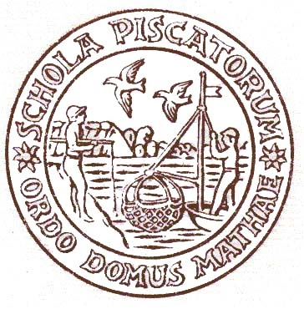
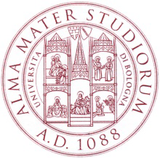
EuroMarine and World Harbour Project joint workshop
Developing ecosystem-based solutions for resilient European harbours and coastal waterfronts (ECORES)
4-6 May 2016, Casa Matha, Piazza Andrea Costa 3, Ravenna, Italy)

Nearly 40 % of the world’s population lives within 100 km of the coast, with working harbours and sprawling infrastructures that are part of the fundamental fabric of those communities. As coasts become more urbanised globally, natural habitats and associated biota are damaged and lost, with consequent loss of environmental quality, vital ecosystem services and livelihoods. Yet ocean and marine environments have been virtually ignored in modern planning, policy and design of cities, and only few conservation initiatives have been carried out in urban areas where people would directly benefit from the ecological services provided by healthy marine ecosystems.

New green approaches are being developed to respond in a more sustainable way to sea level rise and flood risks and to foster production of marine food and renewable energy. While these are essential elements of urban coastal planning, there have been limited attempts to develop a more comprehensive nature-based approach to the design of urban waterfronts. Despite their “novel” artificial nature, the habitats introduced by the urban infrastructures could still support a variety of marine communities and ecosystem services, making them important areas for urban conservation and ecological rehabilitation.

ECORES aims to foster a new focus on “blue” planning and design of harbours and waterfronts of European coastal cities. Building from knowledge and experience of invited participants, ECORES aims to establish a baseline of the status, threats, conflicting uses and main challenges in harbours and waterfronts, and use this knowledge to outline guiding to mitigate the escalating impacts of marine urbanisation and for sustaining marine biodiversity and potential ecosystem services in urbanised marine environments.

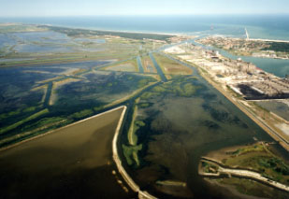
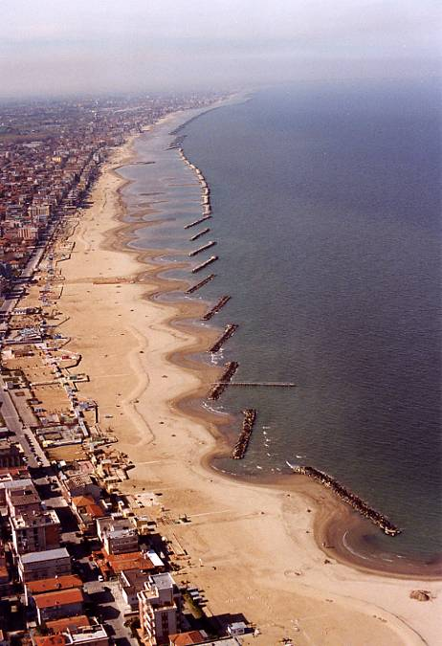
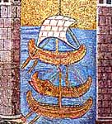

Organised by Centro Interdipartimentale di Ricerca per le Scienze Ambientali in Ravenna (CIRSA) and by Dipartimento di Scienze Biologiche, Geologiche ed Ambientali (BIGEA), University of Bologna, with the support of Fondazione Flaminia

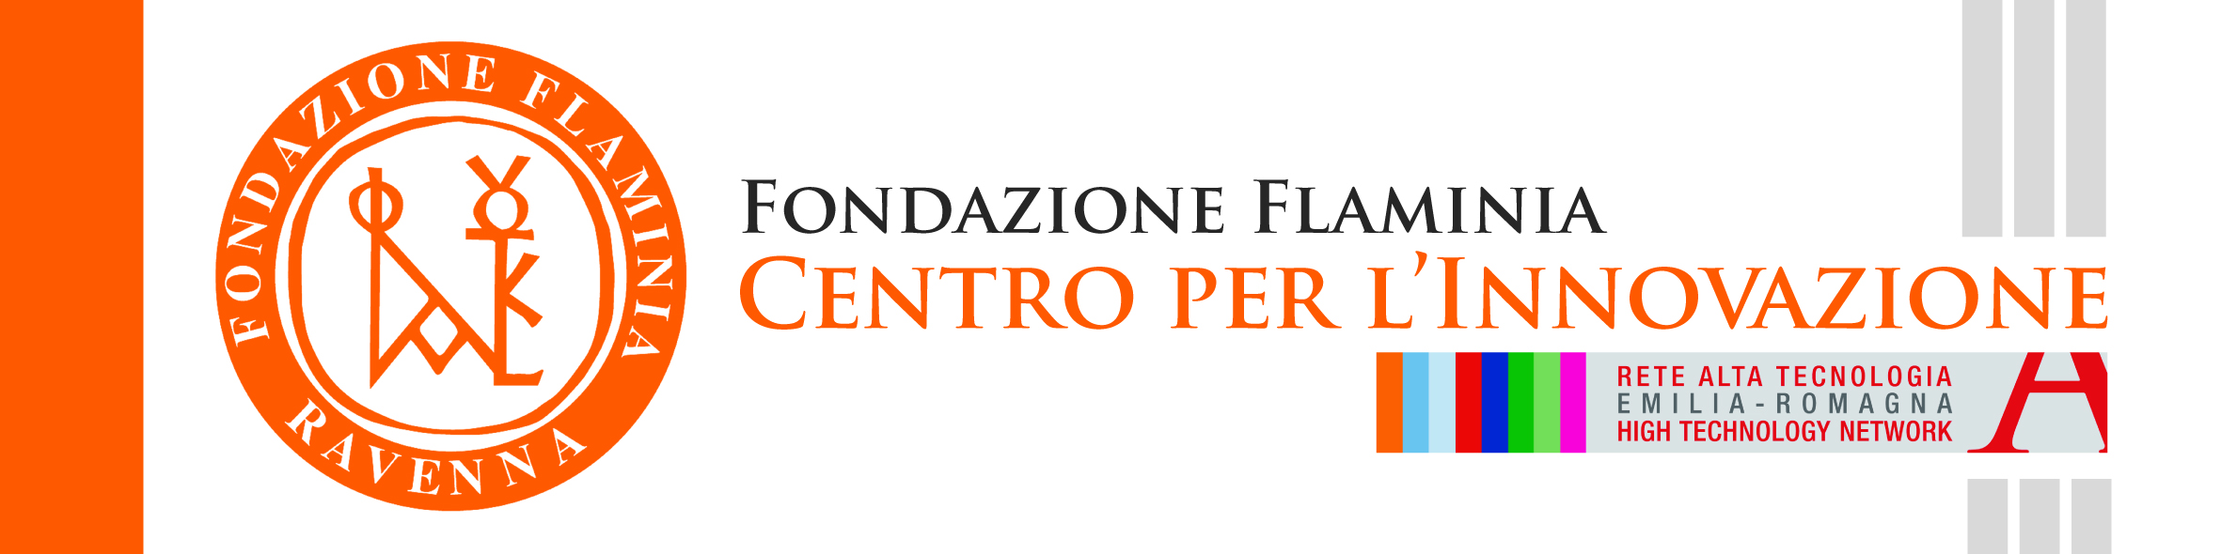
For information please contact:
Prof L. Airoldi, University of Bologna, laura.airoldi@unibo.it
phone +39 0544 937311, mobile +39 320 4386506;
Via S. Alberto 163, I-48100 Ravenna, Italy

Programme
Participation is by invitation – If you are interested please contact Carla Rossi, Fondazione Flaminia,
Via Alfredo Baccarini, 27, 48121 Ravenna RA, Phone:0544 34345, crossi@fondazioneflaminia.it

Wednesday 4 May
09:00-09:15 Welcome: Introduction to the workshop (Laura Airoldi)
09:15-10:00 An overview of Ravenna harbour: priorities, challenges, opportunities and ongoing activities (Alberto Squarzina, Laura Airoldi, Luca Laghi)
10:00-10:30 From grey to blue - a change in perspective: the example of the Sydney Harbour Programme and the World Harbour Project (Peter Steinberg)
10:30-10:45 Sea use change and maritime change in harbour areas –the Dublin Bay example (Marisa Ronan)
10:45-11:15 Coffee break
11:15-11:45 Cumulative impacts, ecological consequences and climate related threats in harbour areas (Fabio Bulleri)
11:45-12:00 Multiple uses, cumulative impacts and marine spatial planning (Simonetta Fraschetti)
12:00-12:30 Pollution issues, monitoring and indicators of environmental quality in harbours (Kenneth Leung)
12:30-12:45 Priorities and challenges in harbours (Christos Arvanitidis)

12:45-14-15 Lunch

14:30-15:00 Green engineering – challneges and opportunities of an ecolofical based sesign of marine infrastructures (Louise Firth)
15:00-15:15 Green engineering in practise (Shimrit Perkol Finkel)
15:15-15:30 Ecosystem services in urbanised areas (Stefanie Broszeit)
15:30-16:00 Coffee break
16:00-16:30 Nature based solutions – incorporating ecosystem restoration in the design of harbours and waterfronts (Tjeerd Bouma)
16:30-16:45 The EU Marine Strategy Directive: the costs and benefits of a good environmental status (Massimilano Mazzanti)
16:45-17:00 Engineering and hydraulic challenges in the design of harbours and waterfronts (Inigo Losada)
17:00-17:15 Conclusions (Laura Airoldi)

18:00-19:30 Guided visit to San Vitale and the mosaics
20:00 - Dinner at Ca Dè Ven

Thursday 5 May
9:00 -10:30 Paper discussion groups
10:30-11:00 Coffee break
12:00-12:45 Paper discussion groups
12:45-14-15 Lunch
14:15 -15:30 Project proposals discussion groups
15:30-16:00 Coffee break
16:00-17:30 Project proposals discussion groups

20:00 Dinner at I Passatelli

Friday 6 May
9:00 -10:30 Project/paper proposal discussion groups
10:30-11:00 Coffee break
11:00-12:45 Project/paper proposal discussion groups
12:45-13:00 Conclusion

Participants
- L Airoldi, Marco Abbiati, Massimo Ponti. University of Bologna, Dipartimento di Scienze Biologiche, Geologiche ed Ambientali, and CoNISMa, Italy - Marine urban ecology; coastal resilience, green engineering and restoration ecology
- F Bulleri - Department of Biology, University of Pisa, and CoNISMa, Italy - Ecology of marine artificial structures; Biological invasions; Human impacts
- T Bouma, University of Groningen, The Netherlands - Ecosystem based adaptation, coastal protection
- T. Crowe, School of Biology and Environmental Science, University College Dublin, Ireland - Ecology of marine coastal benthos
- Peter Steinberg, SIMS - Sydney Institute of Marine Science, Australia – Coordinator of the World Harbour Project
- L. Firth, School of Geography, Earth & Environmental Science, Plymouth University, UK - Ecology of marine artificial structures, ecological engineering
- Shimrit Perkol-Finkel ECOncrete Tech Ltd, Israel - Ecoengineering
- Kenneth Leung and Stefano Cannicci, University of Hong Kong, China - impacts of marine pollution and remediation, marine urbanisation, ecological restoration
- Christos Arvanitidis -Hellenic Centre for Marine Research, Grece - Marine environmental monitoring
- Jesus Troncoso, University of Vigo, Spain – coordinator of dissemination and outreach activities within the World Harbour Project
- Marisa Ronan Trinity College Dublin, Ireland – Maritime heritage and port (creative) cities
- Stefanie Broszeit Plymouth Marine Laboratory, UK– Ecosystem services
- Simonetta Fraschetti, University of Salento and CoNISMa, Italy - Marine spatial planning, multiple stressors
- Patrizio Mariani, DTU Aqua, National Institute of Aquatic Resources, Technical University of Denmark - Physical-biological coupling, fish ecology, numerical modelling
- Giulia Ruta, Luca Laghi, Francesco Matteucci, Elena Casiraghi, CertiMac – coordinators of the project Ravenna Green Port
- Alberto Squarzina, Ravenna Port Authority,
- Ljiljana Ivesa, Center for Marine Research Rovinj, Institute Rudjer Boskovic, Rovinj, Croatia, marine experimental ecology
- José A. Juanes De La Peña and Iñigo Losada, Environmental Hydraulics Institute, Universidad de Cantabria, Spain - Coastal and offshore engineering
- Massimiliano Mazzanti University of Ferrara, Italy - Environmental economics

Waiting for confirmation
- Francesco Regoli, Università di Ancona, Italy – Ecotoxicology, marine pollution and remediation, environmental quality indicators
- Luca Pietrantoni, Università di Bologna, Italy - social and community psychology

