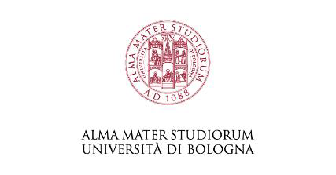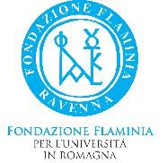

University of Bologna
Department of Juridical Sciences
Ravenna Campus

Summer School on
Cross-Border Insolvency

30 September – 2 October 2021

The lectures will be online / in presence
Ravenna, Italy

Under the patronage of:

Introducing the Summer School

I am Michele Angelo Lupoi, I teach Civil Procedural Law and European Judicial Cooperation at the University of Bologna and I am the Director of the Program of Summer Schools on Transnational Litigation of the Ravenna Campus of the Unibo.
As a matter of fact, the Department of Juridical Sciences of the University of Bologna (Italy), Ravenna Campus, aims at becoming a reference point as concerns cross-border civil litigation for academics, practitioners and students worldwide.
After a very successful Summer School on Transnational litigation: current issues in civil and commercial matters, held in Ravenna (and online), on July 19-23, 2021, we have decided to organize a shorter Summer School (well, actually an Early Fall School, calendar-wise) on cross-border insolvency. Cross-border insolvency is a very interesting area of the law, where civil procedure, private international law, commercial law and other branches of the law meet and melt with each other, often raising very complicate problems which courts from different jurisdictions could be prone to solve in different ways. When a debtor becomes insolvent, private and public interests come into the picture, often leading to conflicts of jurisdictions and conflicts of laws, in a context where forum shopping has become a very sophisticated technique. At the international and at the European level, several uniform law statutes and regulations have been agreed upon and it is fundamental for any practitioner to be familiar with them.
The program of this Summer School deals with some fundamental issues of cross-border insolvency, concentrating, in particular on European harmonized provisions, in a comparative perspective, with both a theoretical and a practical approach.
The Faculty of the Summer School is composed of experts from different jurisdictions, with an academic as well as a professional background.
The Summer School is aimed at law students as well as law graduates and law practitioners who want to obtain a specialised knowledge in this complex and fascinating area of International civil procedure.
The lectures will be offered in part online and in part in a “blended” way (both in presence and online). Participants will have the possibility to attend every class from a Room in the Ravenna Campus of the Unibo.
The pre-registration form and the program of the Summer School may be downloaded from this link:

The registration fee is 50,00 € (it includes the materials provided for by the lecturers and access to the recording of the lectures)

Call for application available here:

https://site.unibo.it/transnational-tort-litigation/en

Info: micheleangelo.lupoi@unibo.it

An application will be made to the Bar Association of Ravenna to grant formative credits for Italian lawyers who participate in the Summer School.
The Summer School Program and Schedule of classes

September 30 | All THURSDAY lectures online
 | (it will be possibile to follow the classes from a room in Ravenna)
9,00 - 9,15 | Michele Angelo Lupoi
 | Opening of the Summer School - Presentation of the program
9,15 - 10,45 | Elina Moustaria
 | Territorialism vs universalism: a comparative perspective
11,00 - 12,50 | Bob Wessels
 | Cross-border communication and cooperation
Lunch Break
15,00 - 16,50 | Antonio Leandro
 | The jurisdictional framework in cross border insolvency proceedings
 | under Regulation (EU) 2015/848
17,00 - 18,30 | Samir D. Parikh
 | The golden age of bankruptcy tourism
October 1 | All MORNING lectures online
 | (it will be possibile to follow the classes from a room in Ravenna)
9,00 - 10,50 | Federico Mucciarelli
 | Applicable law and legal qualifications in the Insolvency regulation recast
11,00 - 12,50 | Rita Gismondi
 | Implementation of the Restructuring Directive no. 2019/1023 across Europe
Lunch break
 | All AFTERNOON lectures will be in presence,
 | with the possibility to attend them online
15,00 - 16,50 | Fabrizio Ravidà
 | The insolvency of groups of companies in Regulation (EU) 2015/848
17,00 - 17,50 | Michele Angelo Lupoi
 | Secondary insolvency proceedings in Regulation 2015/848
October 2 | All SATURDAY lectures will be in presence,
 | with the possibility to attend them online
9,00 - 10,50 | Giorgio Corno
 | Interactive workshop: Regulation (EU) 2015/848 in practice.
 | The standpoint of a transnational lawyer
 | (The attendees will be provided in advance with the details of three cases
 | which will ground the discussion among participants)
11,00 - 12,50 | Michele Angelo Lupoi
 | Interactive workshop: Lawsuits stemming from a proceeding

The Faculty
(in alphabetical order)

Giorgio Corno practices law as an avvocato in Milan (Italy) and heads Studio Corno Avvocati, a boutique law firm established in 1994. He has a long-standing experience in insolvency and restructuring law. He advises mainly insolvency practitioners, debtors as well as credit insurers within national and foreign insolvency proceedings either on Italian insolvency or on on international and cross-border issues. Admitted to practice law in front of the Italian Supreme Court, he is qualified as a solicitor (England and Wales) as well as a certified turnaround professional (EACTP). A founding member of the executive of Ceril - Conference of European Restructuring and Insolvency Law and council member of Insol Europe (Italy reserved seat) since 2015, he is a member of International Insolvency Institute, International Law Association as well as European Law Institute. He contributed as an expert to research projects of the European Commission as well as of other international associations (ILA, ELI, ABI). He regularly lectures and contributes to law publications and reviews, mainly on cross border and international insolvency issues. He acts as an expert for the Italian national foundation council of accountants (Fondazione Nazionale Dottori Commercialisti) on a bulletin issued quarterly on cross border and international insolvency developments. E mail: Giorgio.Corno@studiocorno.it.

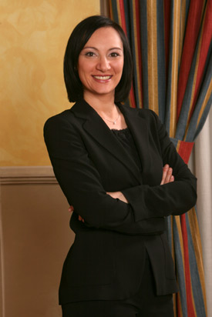

Rita Gismondi, formerly an Associate at Delfino e Associati – Willkie Farr & Gallagher, joined the Italian law firm Gianni & Origoni (Rome office) in 2004, providing advice and assistance in relation to any civil and commercial litigation, as well as restructuring remedies and insolvency proceedings. Rita has gained a deep and significant experience in company crisis and turnaround, reorganization and insolvency legal tools, including relevant litigation proceedings. She handled important insolvency proceedings and restructuring transactions, also in connection with the main extraordinary administration proceedings for large insolvent companies (such as Parmalat and Alitalia). Rita advises domestic and foreign clients, either from debtor’s side, or from creditors’ side, in the framework of different businesses and sectors (e.g. industrial, banking, aviation, telecommunication, food, health, retail and fashion), with focus on any distress or crisis situations in which a restructuring, reorganization or insolvency legal tool is required.
A Fellow of INSOL International (2012) and a member of the INSOL Europe Council (from 2017), Rita is author of various publications and articles in corporate and insolvency law, also in English. She is lecturer in insolvency law, company crisis and turnaround at LUISS Guido Carli University. Rita regularly speaks at conferences and seminars and she is recommended from the directory Who’s Who Legal for restructuring and insolvency.
Rita is a member of the Rome Bar Association and she has been admitted to practice also before the Italian Supreme Court. She can be contacted at rgismondi@gop.it.

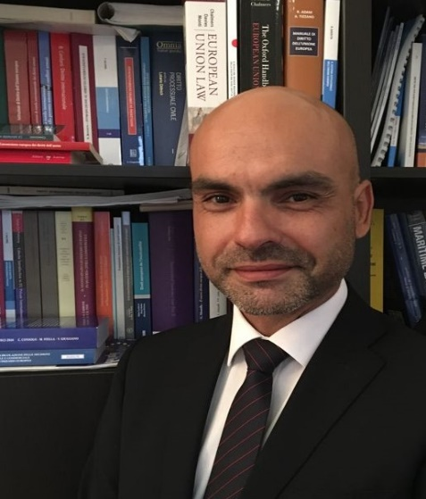

Antonio Leandro is an associate professor of International Law at the Department of Economics, Management and Business Law of the University of Bari Aldo Moro. He gained in April 2017 the Italian National Scientific Qualification (ASN) as a Full Professor of International Law. He is a lawyer admitted to practice before the Italian Supreme Court. Since his PhD at the University of Rome “La Sapienza”, he has carried out several studies on cross-border insolvency, international commercial arbitration, international contracts, international company law, as well as international and European investment law. His bibliography includes three books, five editions, and more than one hundred among articles, notes and commentaries. Particularly, in 2008 he wrote a book on the role of the lex concursus within the European Insolvency Regulation which addresses topics of jurisdiction, applicable law as well as enforcement of judgments. He has been involved as a speaker in judicial and lawyers training projects around Europe such as the project "Cooperation between Members of the Judiciary and other Actors Dealing with Cross-border Insolvency Proceedings" coordinated by the Belgian Judicial Training Institute with the support of the European Union (2014-2015). Currently, he is member of the Extended Group of Experts on Restructuring and Insolvency Law appointed by the DG Justice and Consumers of the European Commission for the initiative “increasing convergence of national insolvency laws to encourage cross-border investment” (2021). Appointed by the same DG, he was member of the Group of experts on improving the efficiency of the enforcement of judgments in the EU – the attachment of bank accounts (2011).
He has been recognized by Lawdragon as one of the 500 Leading Global Bankruptcy & Restructuring Lawyers for 2020. E-mail: antonio.leandro@uniba.it.

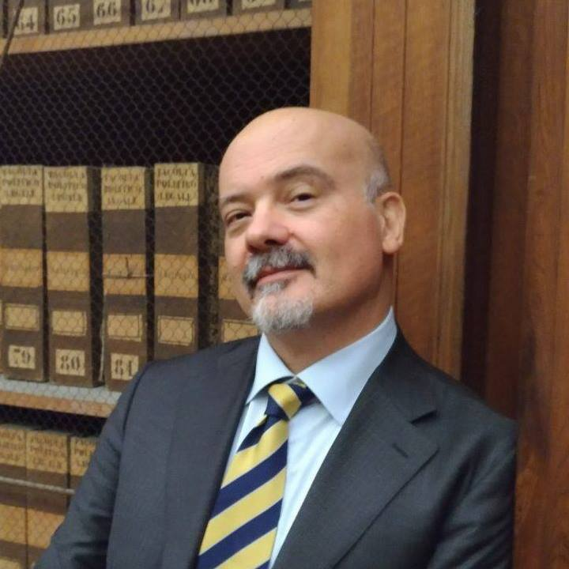

Michele Angelo Lupoi is associate professor of the Department of legal studies of the University of Bologna.
He teaches Civil procedural law (Ravenna Campus) and European judicial cooperation and Civil commercial litigation (Bologna Campus). He is a lawyer of the Bologna Bar Association.
He has written extensively in matters of transnational litigation, cross-border jurisdiction, procedural family law, and other areas of civil procedure. He is an editor of the International journal of civil procedure and of the Rivista trimestrale di diritto e procedura civile and is a member of the Associazione italiana tra gli studiosi del processo civile, the International association of procedural law, and the European association of private international law.
Email: micheleangelo.lupoi@unibo.it.

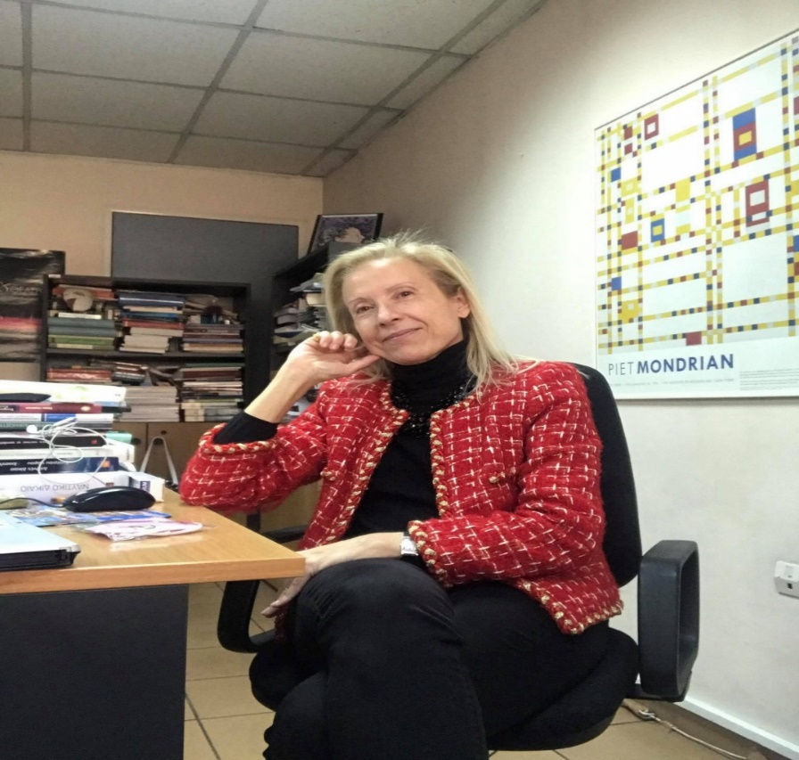

Elina N. Moustaira is professor of Comparative Law of the Faculty of Law, National and Kapodistrian University of Athens, Greece.
She is Deputy Dean of the Faculty of Law, Director of the “LL.M in International Private Law, Law of International Business Transactions & Comparative Legal Studies”, Deputy Director of the “LL.M in International and European Legal Studies” (studies in English), Member of the Supreme Specific Court (2020-2021), Member of various Foreign and Hellenic Law Associations, Delegate of Greece at various Governmental Experts’ and Diplomatic Conferences.
She has written extensively in Greek, English, Spanish, French, Italian. She is the author of 10 books and of about 150 articles, chapters in collective books, commentaries on courts’ decisions, book reviews. Recently, she has published a book on International Insolvency Law. National Laws and International Texts (Springer Verlag, 2019). Prof. Moustaira may be contacted at: emoustai@law.uoa.gr,

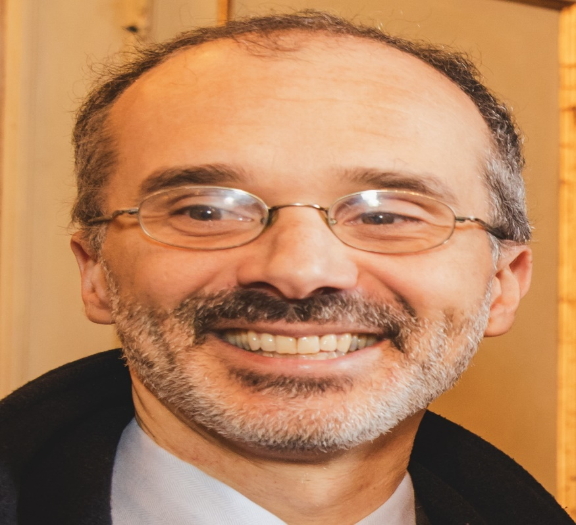

Federico M. Mucciarelli is a full professor of business law at the University of Modena and Reggio Emilia. He holds degrees from the University of Bologna, the University of Heidelberg (LL.M., 2000), and the University of Brescia (Ph.D. in business law, 2003). He was Global Research Fellow at NYU Law School in 2010/2011. Prof. Mucciarelli worked at the University of Bologna (2003 – 2007); he acted as an associate professor at the University of Modena and Reggio Emilia (2007 – 2019) and, jointly, as a reader at the School of Oriental and African Studies, University of London (2012 – 2019). He was visiting scholar at various national and international research institutes and universities, including the Max-Planck-Institute for Comparative and Private Law in Hamburg, the University of Oxford and the Institute of Advanced Legal Studies in London. He was one of the principal investigators in the ‘Study on the Law Applicable to Companies with the Aim of a Possible Harmonisation of Conflict of Laws Rules on the Matter’, drafted for the DG Justice of the European Commission. Prof. Mucciarelli has published in Italian and international journals on topics related to national and international company law, insolvency law and capital markets law, with a particular focus on takeover regulation and international company and insolvency law. In particular, he has published extensively on private international law issues, including recognition of foreign judgments, related to company law, insolvency regimes and takeovers.
E-mail: federicomaria.mucciarelli@unimore.it.

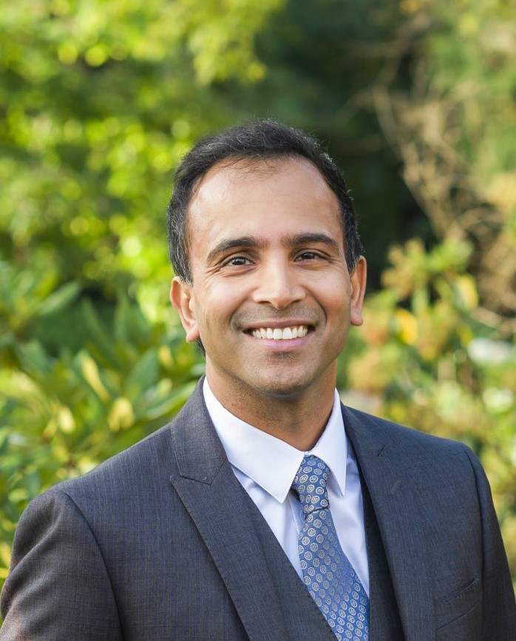

Samir Parikh is a Professor of Law at Lewis & Clark Law School in Portland, Oregon and the Editor-in-Chief of the Bloomberg Law Bankruptcy Treatise. He teaches courses that explore corporate law, financial restructuring, corporate finance, business ethics, bankruptcy, and banking.
Prof. Parikh was a Visiting Professor and Fulbright Schuman Scholar at the University of Oxford in 2019. His article Bankruptcy Tourism and the European Union’s Corporate Restructuring Quandary: The Cathedral in Another Light, was published in the University of Pennsylvania Journal of International Law and is the culmination of his work as a Fulbright Schuman Scholar. The article was one of eight articles selected to be part of the Oxford Business Law Workshop Series (Trinity Term). He has published several articles on financial restructuring matters and regularly serves as an expert witness and policy advisor. Before joining the faculty at Lewis & Clark, Professor Parikh practiced complex financial restructuring at Latham & Watkins, one of the largest and most prominent law firms in the world. He holds a juris doctorate from the University of Michigan Law School. E-mail: sparikh@lclark.edu.

Fabrizio Ravidà holds a Master in Laws from Columbia University School of Law, New York, is a practising laywer in Rome admitted to practice before the Italian Supreme Court and has often served as administrator of insolvency proceedings.
His main areas of prefessional activity are commercial, company and insolvency law.
He has been a counsellor for the Italian Ministry of the Environment and has lectured extensively in his areas of scientific and professional interest. He has presented papers at several conferences, especially in matters of transnational litigation and has written numerous articles and chapters in books on arbitration, civil procedural law, cross-border insolvency and transnational litigation.
E mail: fabrizio.ravida@gmail.com.

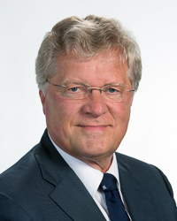

Bob Wessels is Emeritus professor University of Leiden (the Netherlands), School of Law. He was Professor of International Insolvency Law in Leiden (2007-2014) and of Civil and Commercial Law, Vrije University, Amsterdam (1988-2008).
From 1888-2016 he was Deputy Justice at the Court of Appeal in The Hague, and he acted as an international arbitrator and consultant to the IMF and the World Bank. In his independent consultancy he advised with legal opinions or acted as an expert witness in cross-border insolvency and restructuring matters in Dutch courts as well as in the courts of New York, London, Warsaw, Alexandria (Va., USA), Vienna, Dublin, Rhodes (Greece), Zürich, Los Angeles, Stockholm and Antwerp.
He published hundreds of articles in leading legal journals in around ten countries and he (co)authored over thirty books, including ten in English. Since 1999 he is the single author of: Wessels Insolventierecht (Wessels Insolvency Law), a 10 Volume series, published by Wolters Kluwer, The Netherlands. In the 5th edition, since 2018 nine volumes have been published.
Formerly Bob Wessels was Visiting Professor at Johann Wolfgang Goethe University, Frankfurt (Institute for Law and Finance, 2003), University of Pretoria (2004), St. John’s University, New York (2006 – 2011), Riga Graduate School of Law, Riga (2008 – 2012) and Max Planck Institute Luxembourg for Procedural Law (2016).
From 2013-2019 he was Member of the Joint Board of Appeal of the three European Supervisory Authorities (ESAs; ESMA, EBA and EIOPA respectively) and from 2007-2010 Chairman of the Academic Forum of INSOL Europe. His present functions include Expert advisor to the European Commission of the EU regarding matters of (international) restructuring and insolvency (since 2010) and Chairman of the Conference of European Restructuring and Insolvency Law (independent legal think tank) (since 2016).
His activities can be followed via posts on his blog: see www.bobwessels.nl.
E-mail: bwessels@bobwessels.nl.

